Methods Test 2 Notes – Year 11 2023

By Ajay Bisnath

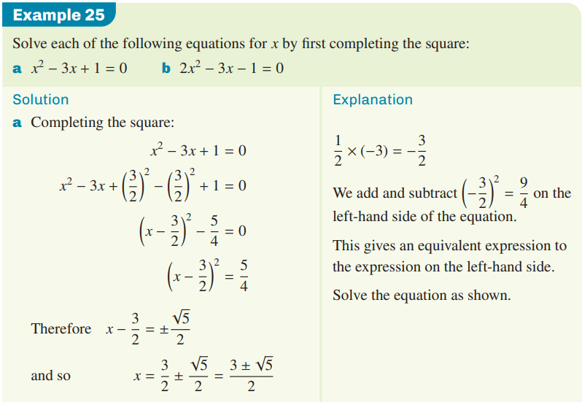

Domain 🡪 Dx: {x $ϵ R$}

or Dx: {x > 0}

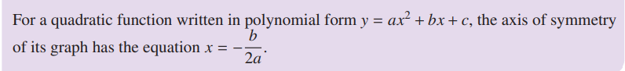

* A screenshot of a computer

  Description automatically generated with medium confidenceb2 – 4ac is the discriminant

Tells us how many x-intercepts

**Factorising by Inspection when a 1:**

2x2 + 9x + 10

2 * 10 = 20

What 2 numbers multiply to 20 and add to 9?

4 * 5 = 20, 4 + 5 = 9

4/2 = 2 🡪 (2x + 5)(x + 2)

**Graph General Equations:**

$$y=a\sqrt{x - h}+k$$

$$y = \frac{a}{x - h}+k$$

$$y = {ax}^{2}+bx + c$$